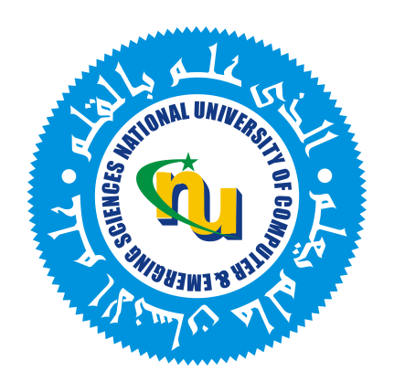

FAST School of Computing
Certificate of Approval
This is to certify that Muhammad Daniyal, Abdullah Siddiqui, Moiz Ansari & Ali Sher have been approved to participate in the community service project titled Orphan Empowerment and Educational Initiative with Muhammadi Foundation.
The purpose of this project is to empower orphans by providing educational support, mentorship, and skill development to help them become confident and self-reliant members of society. This approval is granted based on the evaluation of the project’s alignment with the university’s community service objectives and the student’s academic standing.
Name of instructor: Mahreen Iftikhar
Signature:
Title: Visiting Lecturer
Email address: Mahreenaheen@gmail.com
FAST Sciences and Humanities Department
National University of Computer and Emerging Sciences

Approved By
_______________
Dr. Khadija Farooq
Assistant Professor
Department of Sciences and Humanities
Khadija.farooq@nu.edu.pk
(051) 111-128-128 Ext: 383

